JavaDoc Tool

Author: $Author

Publisher: $Publisher

Date: $date

JavaDoc tool provides extra functions to parse JavaDoc syntax into report variable, then print those value into the output report.. To use a JavaDoc tool in template, you need to import a tool via import statement as shown below:

#import ('javadoc', 'com.nomagic.reportwizard.tools.doc.JavaDocTool')

You can find more information about JavaDoc Tool on MagicDraw ReportWizard UserGuide.pdf section JavaDoc Tool

Code learning:

Parse and create a document for JavaDoc from JavaDoc text
\$javadoc.create(string)

Parse and create a document for JavaDoc from plain text
\$javadoc.createForText(string)

Sample JavaDoc

A sample JavaDoc text in documentation field of operation create().

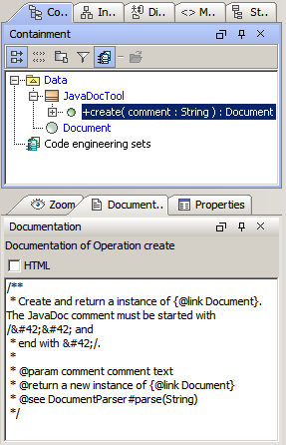

Figure 1 A JavaDoc text from documentation field
Uses method \$javadoc.create(text) to create a document for JavaDoc. Then you can use getTag('tagname') method or directly access to tag name for retrieving JavaDoc properties. The detail of available tag and properties can be found at MagicDraw Report Wizard User Guide.pdf

#foreach ($op in $Operation)
#set ($doc = $javadoc.create($op.documentation))

Operation Name : $op.name
Brief : #foreach ($tag in $doc.firstSentenceTags)$tag#end

Full description : $doc.comment
Parameters :
#foreach ($param in $doc.getTags("param"))
#set($result = $param.name + “ - “ + $param.comment)
- $result
#end
Return : #if($doc.hasReturn())$doc.return#else $empty#end
#end

A sample text with JavaDoc like annotation in documentation field of operation create().

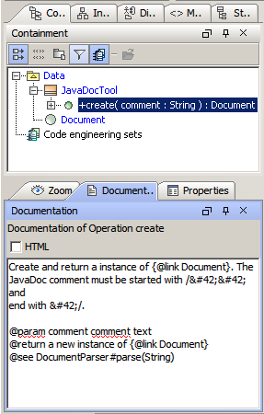
Figure 2 A text with annotation from documentation field
Uses method \$javadoc.createForText(text) to create a document for JavaDoc. Then you can use getTag('tagname') method or directly access to tag name for retrieving JavaDoc properties.

#foreach ($op in $Operation)
#set ($doc = $javadoc.createForText($op.documentation))

Operation Name : $op.name
Brief : #foreach ($tag in $doc.firstSentenceTags)$tag#end

Full description : $doc.comment
Parameters :
#foreach ($param in $doc.getTags("param"))
#set($result = $param.name + “ - “ + $param.comment)
- $result
#end
Return : #if($doc.hasReturn())$doc.return#else $empty#end
#end

